**Chuanr Chef** texture requirements!

Thank you so much for helping with the textures. We loved your work online and we’re really excited to see how much better the game looks once it has an artistic touch :D

Here’s a screenshot from the current game:

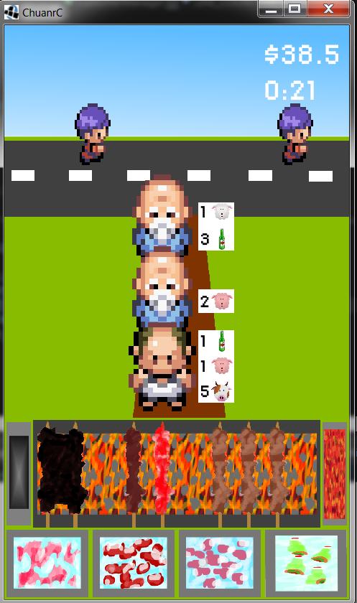

**Game description:**

Android game marketed in China. You operate a street grill where you cook a type of Chinese kebab called “Chuanr.” The setup looks something like this: <http://waiguorenornot.files.wordpress.com/2011/08/beijing_chuanr_cooking.jpg>

**Backgrounds**(5 different areas, 2 static images each = 10 total):

- Each should be 960x720 resolution (4:3)

- Each should have some kind of road/path/sidewalk around 4/5 of the way up the screen (see example backgrounds)

- Everything on the lowest third of the screen will be covered by the grill, so don't worry about filling that in.

- There are two types of backgrounds, one queue line and two queue lines. If you could make both 1 and 2 line versions for each background that would be ideal.

- See the example background images attached for the exact layout

- Dan has sent you 5 images for each of the different areas we need backgrounds for (Village, Outskirts, Suburbs, University, Central Business District).

- Here are some details for each area:

* Village:
* Outskirts:
* Suburbs:
* University:
* Business District:

Here’s the two basic layouts for the backgrounds:

**One path: Two Paths:**

